**Class Exercise – 1.2**

**Name: Ashlyn Cooper**

**Clemson/Assignment ID: PROJ2**

**Submission**: Save this Word document with your answers as a PDF file and upload the PDF file to Canvas.

**Use this file structure to answer the questions below**

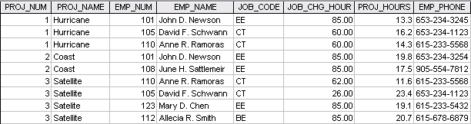

1. **Identify and discuss the serious data redundancy problems exhibited by the file structure above.**
   1. There are multiple duplicate listings for the same employee, and for some employees (like 101) the phone number is different across records of the same employee. Some job codes that are duplicated also have different charges. Also, for the Satellite projects, one of the names is misspelled, which could lead to searching issues.
2. **Looking at the EMP_NAME and EMP_PHONE fields, what change(s) would you recommend?**
   1. I would recommend breaking up the name into multiple fields (first and last name) and for the EMP_PHONE field, I might split that up into two fields, 1 for area code and 1 for phone number.